To use this template, copy and paste the contents into a new document or click “File > download as” to create a word doc if you’d prefer to work offline. If you’re new to Google Docs, head over to <https://www.google.com.au/docs/about/> to get started. Google docs is pretty easy to use (and free!)

## **Project “Dragon” 1-Page GDD**

*Diablo meets Monthy Python*

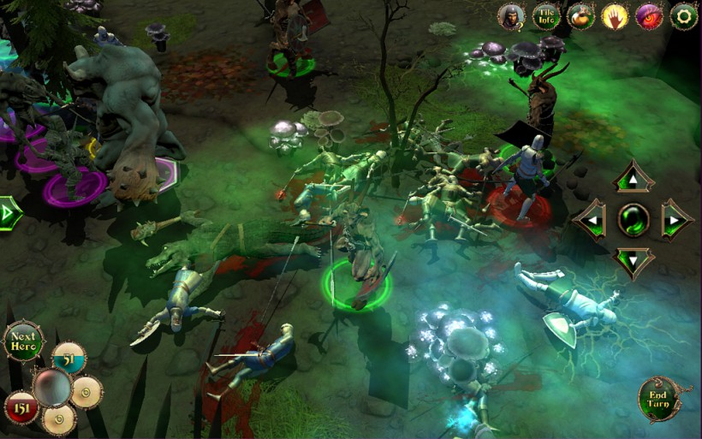

**Genre:** RPG, 3rd person fixed camera RPG.  
**Target Audience:** T for Teen.

**Controls:** Mouse&keyboard and Controller

**Thematic Setting:** Medieval fantasy – swords, knights, dragons

**Tech Stack:** Unity 5+, Blender, Gimp/Photoshop, Audacity

**Platform(s):** Steam

**Game Moment:** Battle with one enemy using special abilities

**Game Summary:**

**Core Player Experience:**

**Central Theme:**

**Design Pillar:**

**Anticipated Remarkability:**

**Anticipated Steam Early Access Launch date:**

**Feature Development Priorities:**

**Comparative Products:**